Understanding Partitions

**Partitioning Styles/Structures**

1. **MBR (Master Boot Record):** A standard layout of information in the first sector of any hard disk or diskette that identifies how and where an operating system is located so that it can be boot (loaded) into the computer's main storage or random-access memory.
2. **GPT (GUID Partition Table):** A standard layout of partition tables of a physical computer storage device, such as a hard disk drive or solid-state drive, using universally unique identifiers, which are also known as globally unique identifiers (GUIDs).

**Volume vs. Partition**

To sum things up, a partition is always created on a single physical disk while a volume can span multiple disks and have many partitions. Within Windows OS, “Disk Management” tool/GUI only shows volumes and not partitions.

**MBR Components**

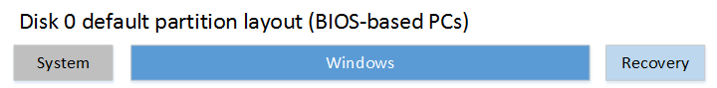

1. **System:** The system partition refer to disk volume containing defined files for the boot of Windows, files such as Ntldr, Boot.ini, Ntdetect.com, bootmgr, BCD, etc.
   1. **Minimum size:** 100MB
2. **Windows:** Also known as the boot partition is where “Windows is installed”. This includes file directories.
3. **Recovery:** As known as Windows Recovery Environment (WinRE) is a side loaded operating system that is install along with your main Windows OS in a separate partition. This can help troubleshoot, recover, and boot from external media.
   1. **Minimum size:** 52MB
   2. **Recommended:** 250MB

**UEFI Components**

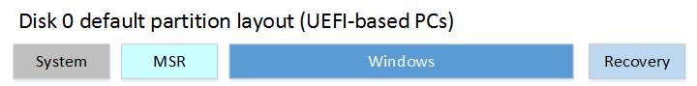

1. **System:** On GPT drives, this is known as the EFI System Partition, or the ESP. The device boots to this partition and so that it can boot your Windows system. This partition is managed by the operating system, and should not contain any other files, including Windows RE tools.
   1. **Minimum size:** 100MB, FAT32
   2. **Recommended size:** 500MB; Even dual booting different Windows versions doesn’t take up much space.
2. **MSR:** This partition is created to reserve a portion of the disk space for possible subsequent usage by the Windows Operating System. This partition does not contain any meaningful data or any user data and **you can’t see this partition in the Windows GUI**. **However, it is assigned and ideally used for remapping damaged sectors.**
   1. **Minimum size:** 16MB
   2. **Recommended size:** 128MB
3. **Windows:** Also known as the boot partition is where “Windows is installed”. This includes file directories.
4. **Recovery:** This is a partition on the disk that helps to restore the factory settings of the OS if there is system failure. This partition has no drive letter. This can be Microsoft stock recovery partition or an “OEM Recovery Partition” (See section below).
   1. **Minimum size:** 300MB
   2. **Recommended size:** This will be dynamic due to WinRE and other recovery tools.
   3. **WARNING:** Windows In-place upgrade (*Ex:* Windows 7 🡪 Windows 10; Windows 10 1909 🡪 Windows 10 20H2) will inject another “Microsoft stock” recovery partition on top of the old recover partition already has.
      1. Please see section “Delete Old Recovery Partition” below.
   4. **Fun Fact!** Windows system restore points snapshots are not held within the “Windows Recovery partition”. Instead, they are held in “C:\System Volume Information” as a hidden OS file.

**OEM Recovery Partition**

Apart from the recovery partition of Windows, there may be another recovery partition created by the computer manufacturer like Lenovo and Dell that has made their computer comes with an OEM recovery partition consuming about 7 to 20 GB, which contains the WinRE, and their factory installation files.

**Delete Old Recovery Partition**

After upgrading the operating system, you will have multiple recovery partitions on your system as seen below. The old recovery partition will become nonfunctional by default and can be removed. You will then need to find out which recovery partition to get rid of. Please use the following steps.

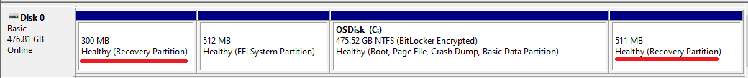

1. CMD (Run as admin) 🡪 “reagentc /info”
   1. This will tell you the current/new/in-use “Recovery partition” you are using and you shouldn’t get rid of.

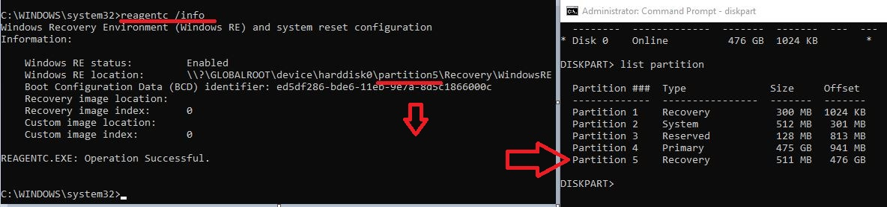

1. CMD (Run as admin) 🡪 “diskpart” 🡪 “list disk” 🡪 Select your disk # “Select disk 0” 🡪 “List partition” 🡪 Select partition # “Select partition 1” 🡪 “delete partition”.
   1. #2 is just an example.